EXPERIMENT-25
25) Recognize watch from the given image by general Object recognition using Open CV.
a)CODE
import cv2
import os

path = os.path.join(os.path.expanduser("~"), "Desktop", "photo.jpg")
img = cv2.imread(path)

if img is not None:
cv2.putText(img, "Watch", (20, 40),
cv2.FONT_HERSHEY_SIMPLEX, 1, (0, 255, 0), 2)
cv2.imwrite(os.path.join(os.path.expanduser("~"), "Desktop", "watch_output.jpg"), img)
print("Output saved on Desktop")
cv2.imshow("Watch Recognition", img)
cv2.waitKey(0)
cv2.destroyAllWindows()
else:
print("Image not found! Check photo.jpg on Desktop")

b) INPUT
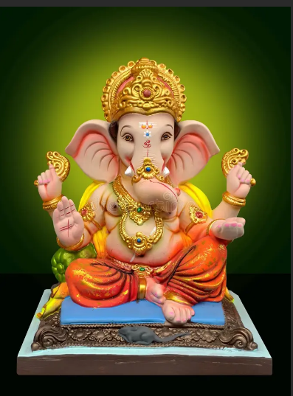

C) OUTPUT
